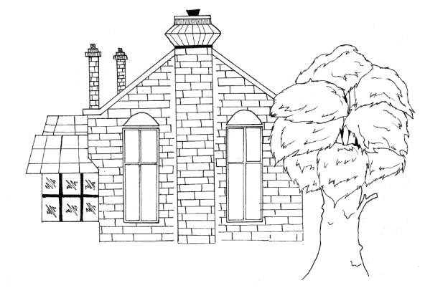

Champney Hall Management Committee
A Registered Charity: 241474
Champney Hall, Stanwell Road, Horton, SL3 9PA
E: Champney Hall@gmail.com

To book Champney Hall
please contact
Sam 07917 684040

Or email
ChampneyHall@Gmail.com

For other matters relating to the hall please contact Benta 07957 588277

