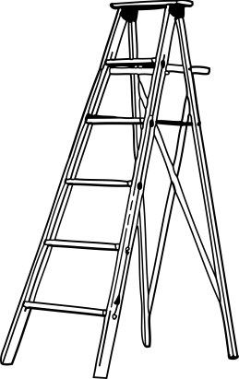
CHAMPNEY HALL , HORTON

GUIDANCE FOR ANYONE WORKING
ALONE IN THE HALL.

For the most part we would advise that people would work together.
The following guidance applies when that is not possible.

Please ensure that somebody knows where you are and how long you expect to be in the hall and about the time you expect to leave. Wherever possible, carry out all tasks during the hours of daylight.

If you are not a key holder make absolutely sure that you have the phone number of the person who gave you the keys so you are able to contact them.

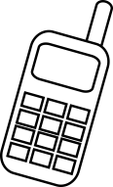
If you have unlocked the main gate please ensure that it is locked in the open position.

Make sure that you have a mobile phone with you and carry it with you, not left in a bag. If you do not have one, the first instruction is particularly important.

Close the outer main door while you are inside. We would advise that you do not lock the doors. You may want to wedge open the inner glass doors which are self-closing.

Please do NOT use step ladders or scaffolding unless there is somebody else with you.
When you leave, please turn off all lights, heating and power switches, particularly if you have been in the kitchen.

Finally, please lock and check the external doors as you leave, and also the yellow gate (unless someone else is using the hall at the time.)

Thank you very much for all your help.
These notes are simply to ensure everyone's safety.

Champney Hall Trustees

